SigmonLED
IR User’s Manual
for version 3.2

Table of Contents
Welcome 1
Input Light 2
Color Mode 3
Color Presets 4
Select Mode 5
Changing Hue 5
Changing Saturation 5
Palette Mode 6
Value Types 7
Wiring Diagram 8

Welcome
SigmonLED is an Arduino controller for WS2818 and similar programmable LED strips. The Arduino can be controlled over Bluetooth with compatible devices/software, or through an infrared remote.

This package should contain the following:
- Arduino Uno, preloaded with SigmonLED
- WS2818 LED strip
- 5V DC Power Adapter
- IR remote with receiver

WARNING: You should NOT plug the DC power adapter directly into the Arduino! Instead, plug the barrel jack into the plug coming from the LED strip.

This manual will teach you how to use the IR remote with your SigmonLED-powered Arduino.

Input Light
The input light is solid yellow if the last button press was misinterpreted. You may need to press the button again.
Input Light
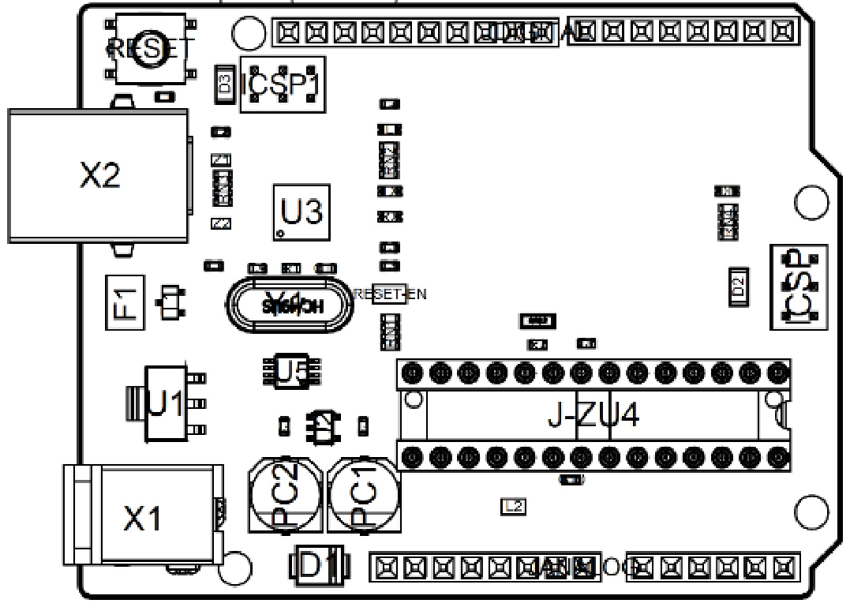Figure 1: Arduino Uno
Blinking yellow indicates certain modes. See the section on Palette Mode for more information.

Color Mode
This is the default mode when the Arduino is first powered on. The LEDs will remain dark.
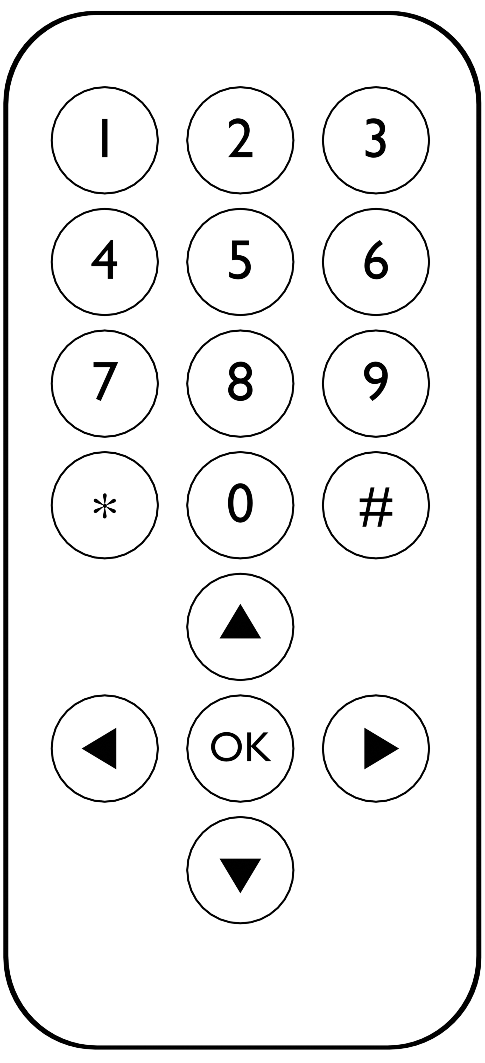Figure 2: IR Remote

OK | Turns LEDs on/off
▲ | Turn brightness up
▼ | Turn brightness down
✱ | Switch to Palette Mode
# | Switch to Select Mode
Numbers | Select preset color

Color Presets
Color presets can be selected while in Color Mode by pressing a number on the remote. These presets can be changed by selecting the preset and then entering Select Mode by pressing #. Note that if the Arduino loses power, it will reset all presets back to default. Here is a list of the default presets:
1 | Warm White
2 | Red
3 | Orange
4 | Yellow
5 | Green
6 | Teal
7 | Blue
8 | Purple
9 | Magenta
0 | White

Select Mode
This selects a color for use in Color Mode. When the mode is first entered, the LEDs will flash a rainbow to indicate you are changing the Hue of the color. While in this mode, the LEDs will intermittently flash to indicate they are still in Select Mode.

Changing Hue
When you start changing the color hue, the LEDs will flash a rainbow, and then return to your currently selected hue. You can change the hue with ▲ and ▼. Pressing ► will select the Saturation of the color.

Changing Saturation
When you start changing the color saturation, the LEDs will flash a gradient of your current hue fading to white, and then return to your currently selected hue and saturation. You can change the saturation with ▲ and ▼. Pressing ◄ will go back and select the Hue of the color. Pressing ► or OK will finalize your selection and return to Color Mode.

Palette Mode
This mode will scroll the entire LED strip through a selected color palette. You can customize the behavior of this using the number pad and arrow keys on the remote.
Figure 3: IR Remote

OK | Turns LEDs on/off
▲ | Increase current value
▼ | Decrease current value
✱ | Switch to Color Mode
# | Toggle blending

Value Types
The Number Pad can change the current value type being modified by ▲ and ▼:
1 | Brightness
2 | Color Palette
3 | Scroll Speed
4 | Palette Distribution
5 | Scroll Style

When Palette Mode is initially entered, the current value type will always be Brightness.

Wiring Diagram
